Coursework Cover Sheet
Students should complete the input fields contained in this form and attach it in front of your formal assessment submission. All fields within this form are required. Please ensure that check boxes and radio buttons are appropriately selected. The last three questions are just for you to personally consider.

Department and assessment information:
School Name: Engineering and Computing
Assessment title: Group Development Project
Course Title: Group Development
Module Title: The AGILE Professional
Module Code: CO2007
Year of Study: 2025/2026

Academic Misconduct / Plagiarism Declaration
By attaching this front cover sheet to my assessment I confirm and declare that I am the sole author of this work, except where otherwise acknowledged by appropriate referencing and citation, and that I have taken all reasonable skill and care to ensure that no other person has been able, or allowed, to copy this work in either paper or electronic form, and that prior to submission I have read, understood and followed the University regulations as outlined in the Academic Integrity Policy and Procedure for Academic Misconduct

Have you checked the following? This will help your assessment achievement.
I have applied the learning outcomes for this module ☒
I have checked for Academic Integrity via Turn-it-in ☒
I have followed the guidance in the Assessment Brief and have not used AI to boost my grade unfairly. ☒
I have used references in accordance with instructions in the Assessment Brief ☒
I have proofread my work for spelling, grammar and punctuation. ☒
I have checked that the word count/size of this submissions accords with the guidance provided in the Assessment Brief.☒

Well-being
We wish to support any student who is experiencing mitigating circumstances which prevents students from performing to the best of their ability when completing or submitting assignments. If you are experiencing such circumstances, then you may apply for Mitigating Circumstances. Wherever possible this must be done prior to handing in your assignment.

Do you need to apply for mitigating circumstances for this assignment No

Please refer to the Mitigating Circumstances Policy

Questions you may wish to consider:
- Have I allowed sufficient time to prepare this assessment?

- Have I reflected on previous feedback and made improvements in accordance with advice?

- What grade am I expecting?

Scrum Board (Kanban board) – Team D (Manager).

Link to our Kanban Board - https://omiduhansaja.atlassian.net/jira/software/projects/PJM/boards/1
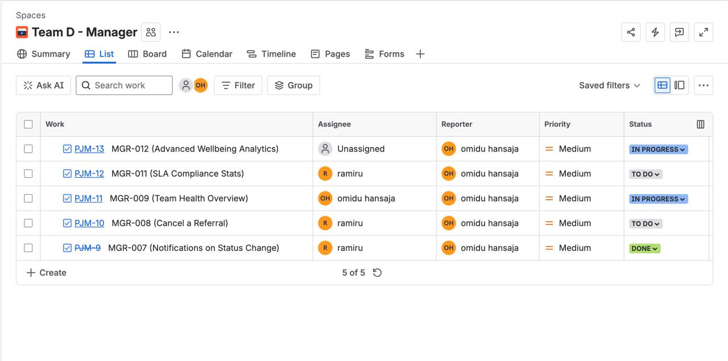
Kanban Board (During the Project).
